**Chapter 16 - Prototype**

Prototypes are the mechanism by which javascript objects inherit features from one another.

**Eg**:

Const myObject={

city:’Madrid’,

greet(){

console.log(`Greetings from ${this.city)`);

}

}

myObject.greet(); // Greetings from Madrid

myObject.toString(); // “[object Object]”

In the above example myObject{} is an object which has one data property, city and one method, greet().

When the browser executes myObject.greet(), it checks for the greet() method in myObject{}, it is present so it executed.

When the browser executes myObject.toString(), it checks for the toString() in myObject, it is not present in the object so it checks for the prototype toString().

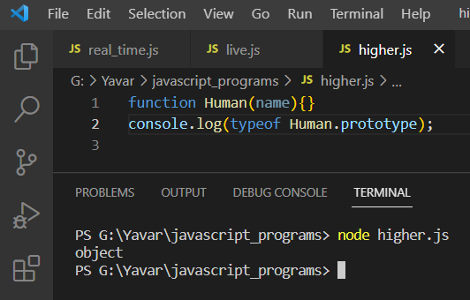

**Prototype on Object literal:**

When an object is created, its prototype would be object

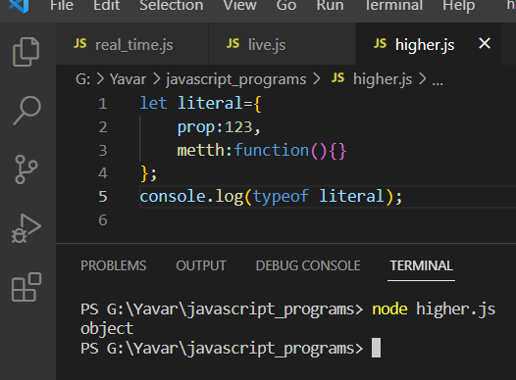

**Prototype link:**

When an object is instantiated usig new keyword, the constructor function executes to build the instance of that object.

